Building a Print Washer

Tools required
- Hand Saw
- Knife (to score Plexiglas)
- Drill motor (and drills)
- Silicone Caulk Applicator
- Clamps to hold the box from end to end

Materials required
- 1x2 lumber (preferably redwood)
- Silicone Caulk (waterproof, preferably clear)
- Female garden hose connector
- Plexiglas sheet
- Waterproof wood glue

Design
The print washer is made up of Plexiglas, with wood holding it together. Individual 'paper compartments' are divided by Plexiglas within the outer box. There is a small area below the compartments where the water enters the box and then enters the individual compartments through holes in the 'false bottom'. This box sits on a base of 3/4" lumber (1 by). The wood around the top and bottom is there to hold the box together.
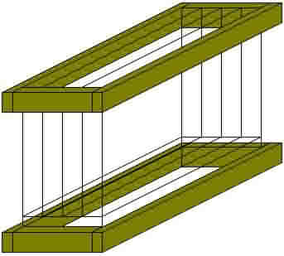

This diagram shows the box without the wood attached. The box is 10 1/4" high, 6 1/2" wide, and 11 1/2" long. There are 6 dividers making 7 compartments of 9"x11"x3/4" each. You can build your washer to whatever dimensions you want though.
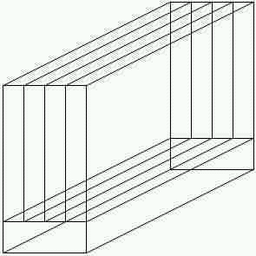
The sides, ends, bottom, and dividers are all cut from Plexiglas. I don't remember the size of the Plexiglas sheet(s) I purchased, it was 10 years ago, but the dimensions of the pieces are as follows.
• Sides (2) 10 1/4" by 11 1/2".
• Ends (2) 10 1/4" by 6 1/2"
• Dividers (6) 9" by 11 1/4" (11 1/2" minus twice thickness of the Plexiglas you purchase)
• Bottom (2) 6 1/4" by 11 1/4" (fit inside the outer shell)
The false bottom has holes in it of 1/8" diameter to allow the water to flow from the bottom compartment into the individual paper compartments. The holes should be centered where the paper compartment will be. (I've drawn more columns in this drawing than there are in my washer, sorry). Put them about 1 to 1 1/2" inches apart.
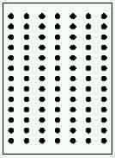

Calculations
- Determine the size you want your compartments to be. I found that if the compartments were not too deep, 3/4" was plenty to put my fingers into to get the paper, if I use this washer with 5x7 or smaller prints, I have to use a thin set of metal tongs to remove the prints.
- Determine the number of slots you want.
- Calculate the size of the box you want (allow 1" for the bottom compartment).

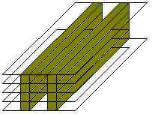

Assembly
- Cut the Plexiglas sheet into the sizes for the pieces you need. (score one side of the Plexiglas with a sharp knife, run along a straightedge (preferably metal) then 'snap' the sheet in two. Be careful doing this, you need to make sure that you cut only once, and that it is a definite 'score'. If you cut twice, you are likely to make two 'scores' in it, and then when you snap it, it will break weird.
- Cut the holes in the false bottom. When you drill, start out slow, because Plexiglas is slippery, and you might slide all over the stuff if you aren't careful.
- Stack the sheets using 1x4 spacers as shown. The dividers should be lined up with the top sides and slightly inside of the ends of the sides. (don't worry about getting the ends lined up, they will be adjusted as you connect the ends) The wood used in the stacking should not be glued to the Plexiglas, it is just used as spacers.
- Apply silicone caulk to the ends of the sides and dividers (the ends need a lot of caulk to prevent leaks, the dividers only need enough to keep them from moving about.
- Put more silicone on the ends where they come in contact with the sides, before attaching them.
- Connect the ends to the sides and dividers. Keep the tops of the dividers in line with the tops of the sides. Clamp the ends to the sides and dividers.
- Wait until the silicone is dry.
- Apply silicone to the inside of the box where the false bottom will sit, and on the bottoms of the dividers.
- Insert the false bottom, place the box top side down on something hard, and put weights on the false bottom so that it seals well.
- Wait until the silicone is dry.
- Apply silicone to the inside of the box at the bottom edge.
- Insert the bottom into the bottom of the box, and allow to dry.
- Cut the 1x2 wood into lengths that will allow an overlap of the thickness of the wood on all sides. (if the wood is 3/4" thick, and you are making your washer to my dimensions, you need to make pieces that are 8" for the ends, and 12 1/2" for the sides. You need 4 ends and 4 sides. Plus, you should make a row of them for underneath the box (I had 5 1x2x12 1/2" pieces for the base).
- Cut interlocking tenons in the ends of the wood. Allow a little extra length in the tenons so that there is room to tighten the clamp during glue up.
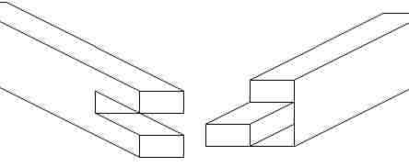
tenon - A way to join pieces of wood which increases the amount of wood surface for gluing. There are many kinds of tenons, this is an end to end tenon.

- Apply silicone to the outside of the box where the wood will be (that is the only way to glue wood to Plexiglas that I know of)
- Glue the tenons and clamp the wood in place. Be sure this is clamped tightly. Allow to dry.
- When the glue is dry, drill a hole in the center of the wood on either the end or the side, your choice, large enough for a snug fit of the female hose connector, and all the way through the Plexiglas into the lower compartment. Apply silicone and insert the connector into the wood.
- Drill a small hole (3/32" or 1/8") on the opposite side / end of the bottom compartment near the bottom. This is the drain, so it needs to be right at the bottom of the bottom compartment to get the water out when you are finished your session.
- When everything is really dry, test for leaks. If you have leaks, put additional silicone on the corners where the leaks are. If you can't get it to hold it's shape, wrap 12 gauge wire around the box in bands, and twist the ends to tighten, or build another row or two of wood holders.
- When there are no more leaks, silicone the base pieces to the bottom of the box.

Using your print washer
Allow enough water flow to just barely come over the top of the washer, so it needs to flow a little faster than the water exits through the drain hole in the bottom. To 'archivally' wash prints, you need to test the washer before you can know the exact wash times. But I have found that with wash aid, and a pre-wash, I need 9 to 10 minutes within this washer for 'archival' quality. Your definition of archival is probably different to mine, so don't use my numbers!
Note: If you put more than one print into the washer, you need to wash all prints to the length of time required for the last one, since there will always be some dissipation of fixer from one compartment to another if you use one source of water, no matter what the design of the washer is.
Versalab Print Washer FAQ information applies to all print washers, including this one.
Have fun printing!

